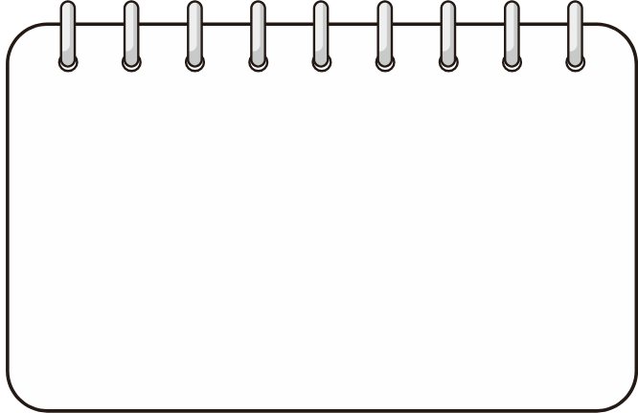
Administrador: Organitzar i recordar a cadascú els seus rols. Guardar el material.
Portaveu: Comunicar a les posades en comú els resultats i contribucions de l’equip.
Secretari 1: Redactar les justificacions.
Secretari 2: Apuntar les dades i la informació important.
Date:

Bottle number:
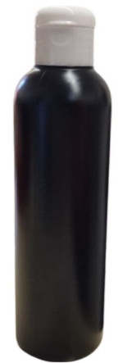
Team members:
Administrator
Spokesperson
Secretary 1
Secretary 2


Systematic experiment
Queda totalment prohibit obrir l’ampolla en cap moment!
Qualsevol equip que no segueixi aquesta norma, serà penalitzat i no podrà continuar realitzant l’activitat.
Our goal is to find out what the contents of the mystery bottle we gave you are.
With the current information, fill in the following table:


What can we know? ✅ | What can't we know? ❌

New information: The bottle contains a total of ____ elements.
Data collection
We are starting to collect data. You have until the end of the session to collect information about the composition of the bottle and state some hypotheses.


Conclusions : Hypotheses on the composition of the bottle
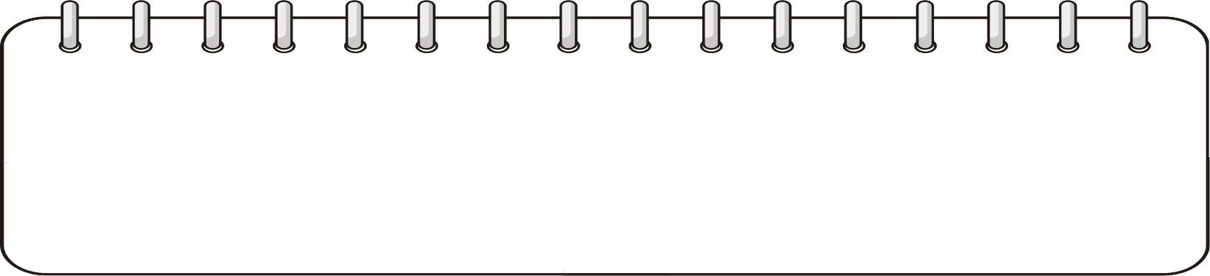
Confidence level
Mark where you would place your level of confidence in your hypotheses:
Gens segur Poc segur Bastant segur Totalment segur

